**Unit 1.5 - Worksheet 2**

**Working with Expressions in Pyret, Part 1**

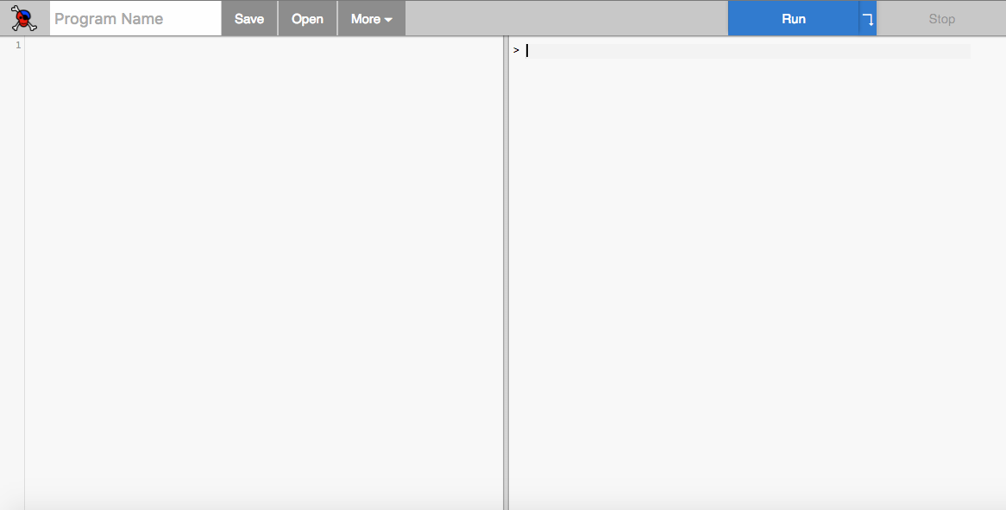

Definition

Side

Interaction Side

In your browser, go to:

<http://code.pyret.org/>

For the first few questions we will work on the right (*Interaction Side*) of the Pyret screen.

# **Values in Pyret**

1. What happens when you *type* values into the interaction window of Pyret and press *‘enter’*? Fill in the table below. Make predictions first and then try it in Pyret. If you get a feedback message, what do you think this message is telling you?

|  |  |  |  |
| --- | --- | --- | --- |
| **What you type** | **What kind of value is it?** | **Prediction** | **Observation** |
| **5** |  |  |  |
| **“Hello”** |  |  |  |
| **3.14** |  |  |  |
| **5.00** |  |  |  |
| **Hello** |  |  |  |

# 

# **Expressions in Pyret**

1. What happens when you *type* the following examples into the interaction window of Pyret and press *‘enter’*? Fill in the table below. Make the predictions first and then try it in Pyret. If you get a feedback message, what do you think this message is telling you? For each expression listed describe what the expression does or explain why it yielded a message.

|  |  |  |  |
| --- | --- | --- | --- |
| **What you type** | **Prediction** | **Observation** | **Describe/Explain** |
| **5 + 6**  ***(with spaces)*** |  |  |  |
| **5+6**  ***(without spaces)*** |  |  |  |
| **5 * 6** |  |  |  |
| **3.14 - 2.1** |  |  |  |
| **1 / 2** |  |  |  |
| **1 / 3** |  |  |  |
| **(2 + 7) * 3** |  |  |  |
| **2 + 7 * 3** |  |  |  |
| **“Hel” + “lo”** |  |  |  |